Go to: https://www.compass.state.pa.us/cwis/public/home
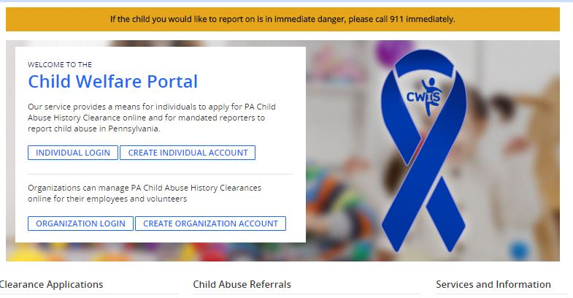
Click Create Individual Account
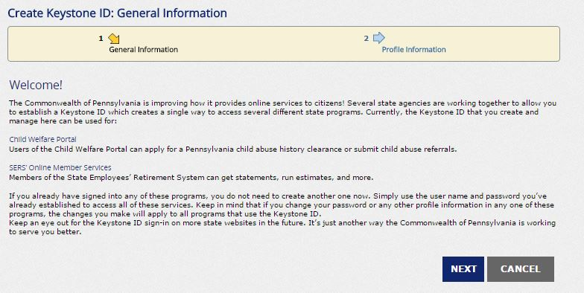
Click Next
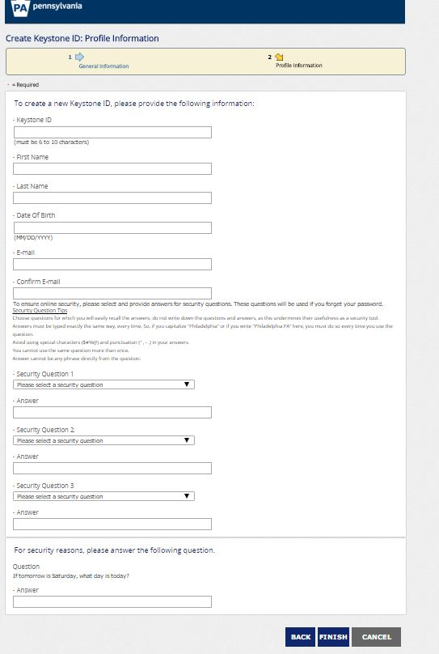
Create a Keystone Id – Be sure to answer ALL questions (No Blanks) & FINISH

You have successfully created a Profile. You will receive 2 emails to the email address you entered. The first will contain your Keystone ID and the second will contain your Password. You can close this window.

Go back to: https://www.compass.state.pa.us/cwis/public/home
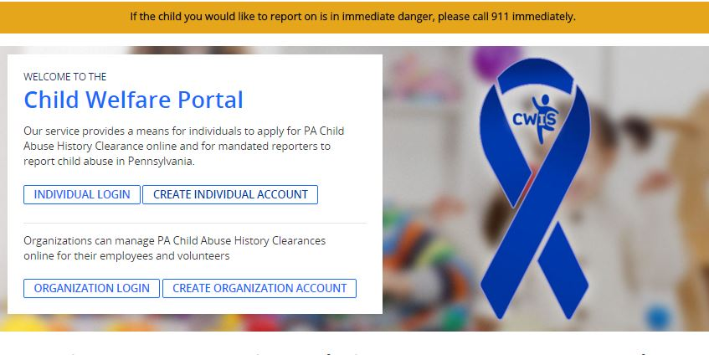
Click Individual Login
Click Access My Clearances
This will first direct you to an informational page, scroll to the bottom (after reading) and click Continue.
Input the Username and Password that was emailed to you.
You will be prompted to change your Password.
To ensure online security, the Commonwealth of Pennsylvania requires passwords that :
- are at least eight characters long.
- contain at least one number.
- contain at least one upper case letter.
- contain at least one lower case letter.
- contain at least one special character, such as @&*%$^.
- do not include any of your user name, your first name, or your last name.
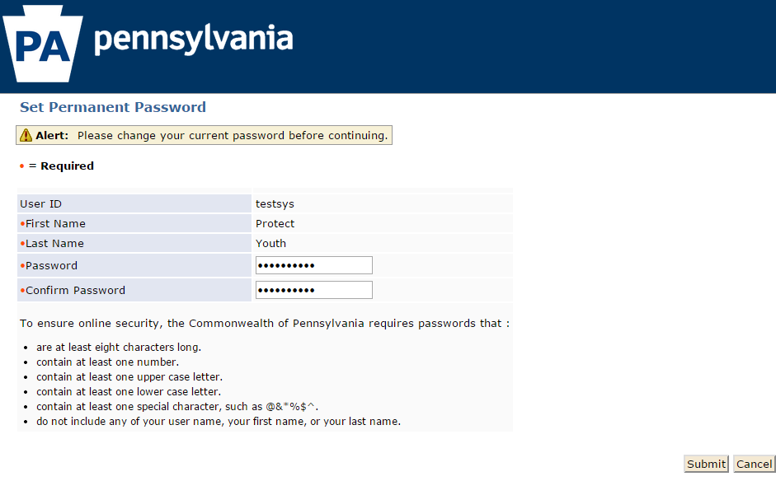
Once you create a new Password, and enter it in both boxes, click Submit.
On the next screen, click Close Window and the system will return to the logon screen. Enter your Username and new Password and click Login.
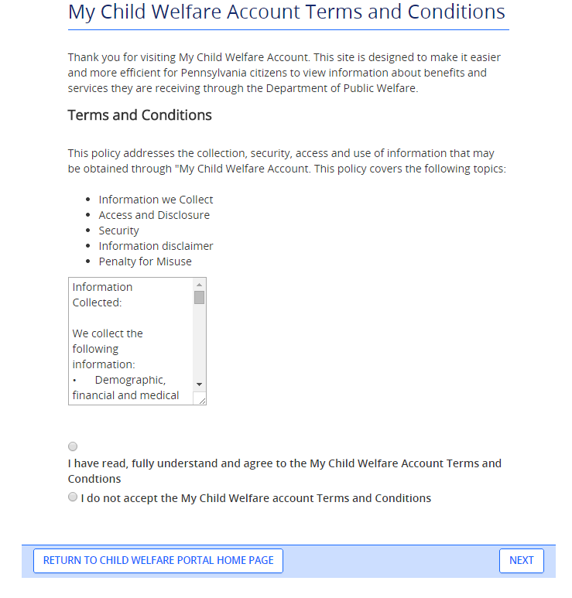
Read and Accept the Terms and Conditions, click Next.
The next page is another informational page, please read before clicking Continue at the bottom.
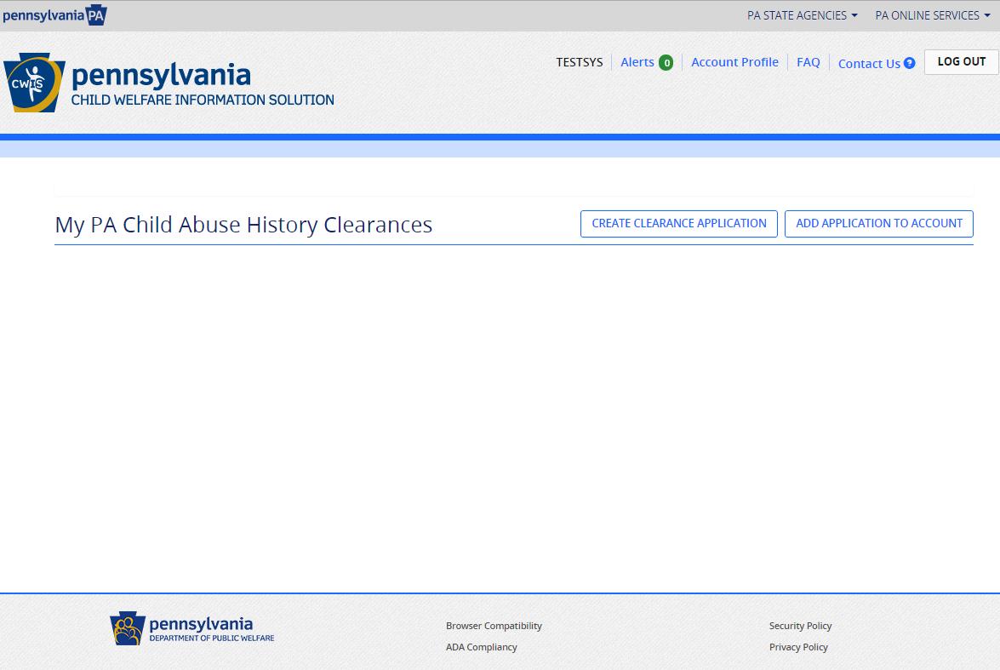
You are now ready to start your clearance application. Click Create Clearance Application.
Please read through the informational page, it includes important information regarding what information you need to fill out the form. Click Begin at the bottom of the page when you are ready to start the clearance.
The system will guide you through the steps, when you reach the last section, Application Payment, use the code sent to you by your organization.
If you have questions:
- For questions regarding your Child Abuse Referrals, contact ChildLine at 1-800-932-0313.
- For questions regarding your Pennsylvania Child Abuse History Clearance Application, contact ChildLine at 1-877-371-5422.
- For assistance with your account log- in or other technical issues, contact 1-877-343-0494.

